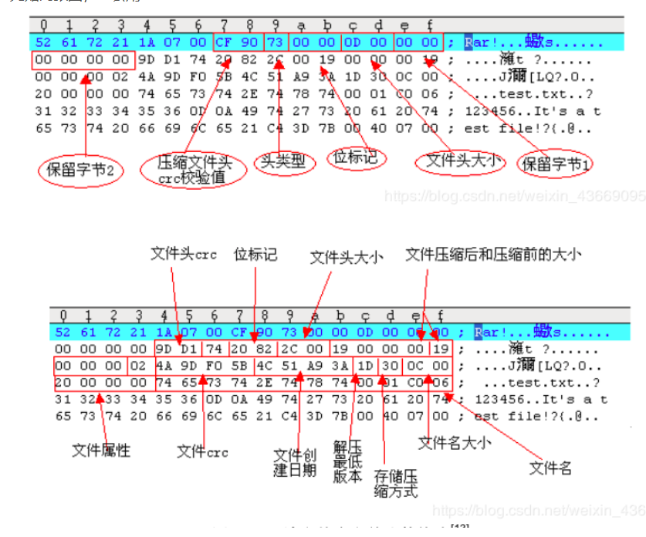CRC校验原理及压缩包位置

针对该题的脚本

import zipfile

import string

import binascii

def CrackCrc(crc):

for i in dic:

for j in dic:

for k in dic:

for h in dic:

s = i + j + k + h

if crc == (binascii.crc32(s.encode())):

f.write(s)

return

def CrackZip():

for i in range(0,68):

file = 'out'+str(i)+'.zip'

crc = zipfile.ZipFile(file,'r').getinfo('data.txt').CRC

CrackCrc(crc)

dic = string.ascii_letters + string.digits + '+/='

f = open('out.txt','w')

CrackZip()

print("CRC32碰撞完成")

f.close

